Automate httpd server using jenkins job

-Shweta Raut

1. Install java-17 and git
2. Download tomcat server

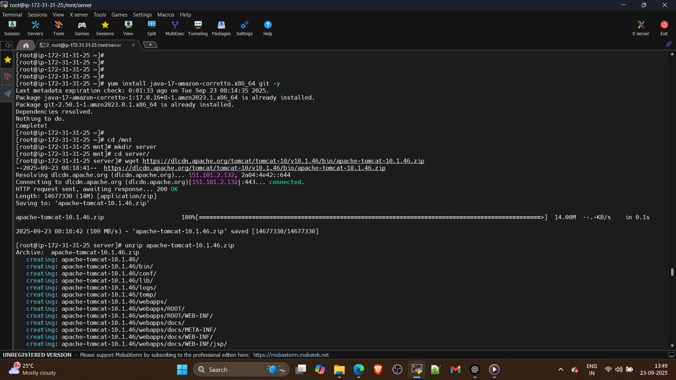

3. Install Jenkins from WAR

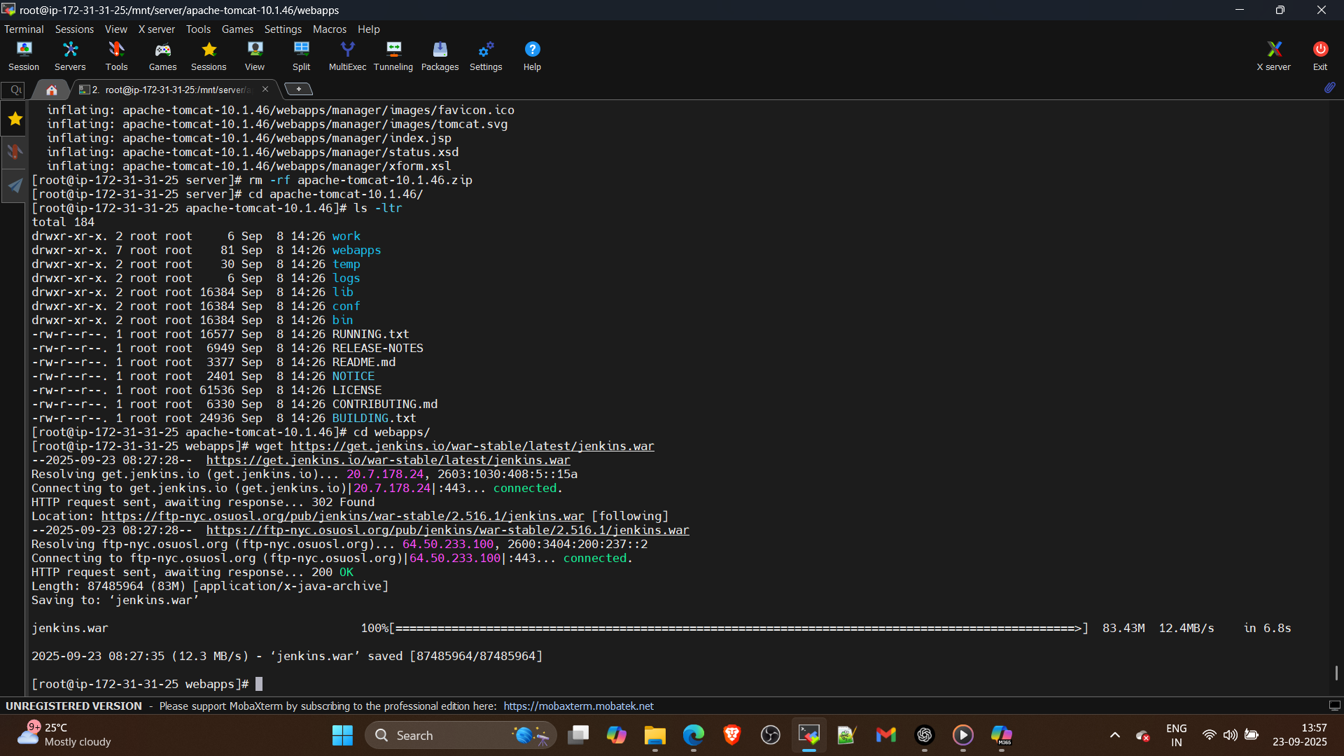

1. Start the startup.sh

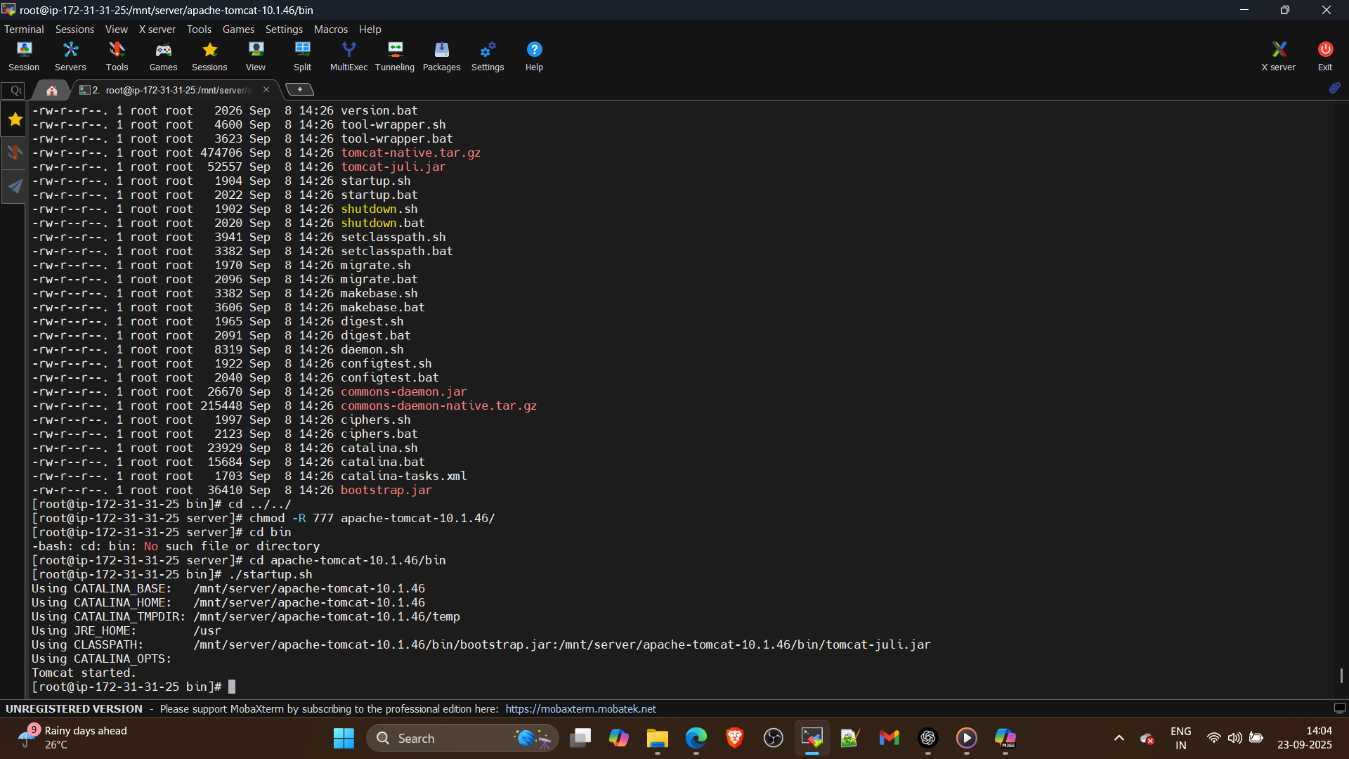

1. Access the jenkins on browser create a dashboard

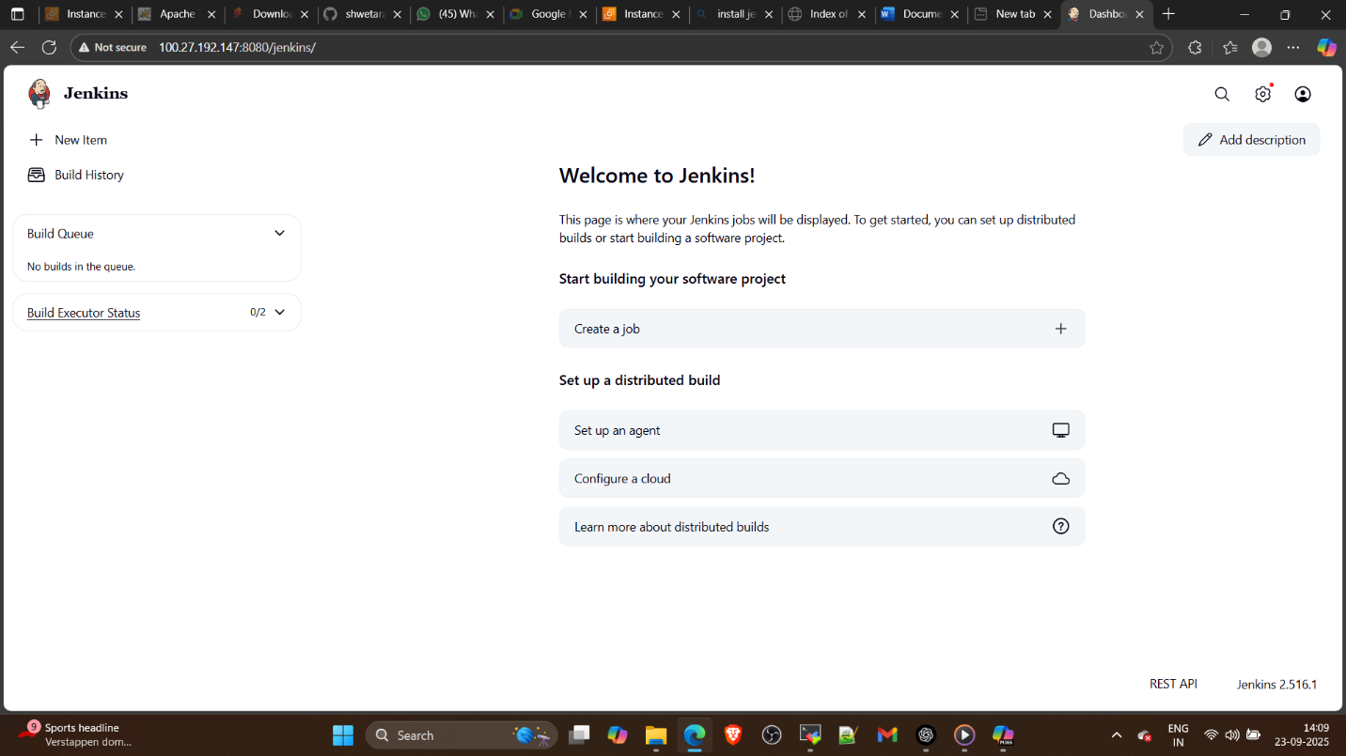

1. Jenkins home on jenkins master

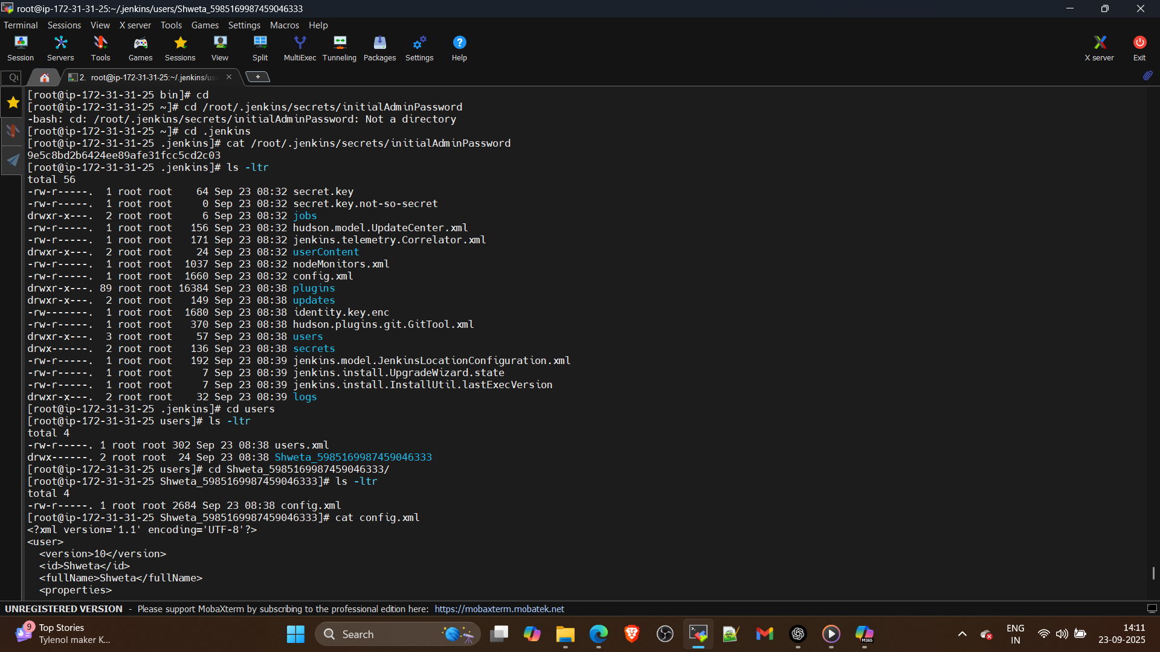

In jenkins home

Users folder for jenkins own user database

Plugins save in plugin folder

Jobs folder

Logs

1. Create a job on jenkins dashboard in freestyle job

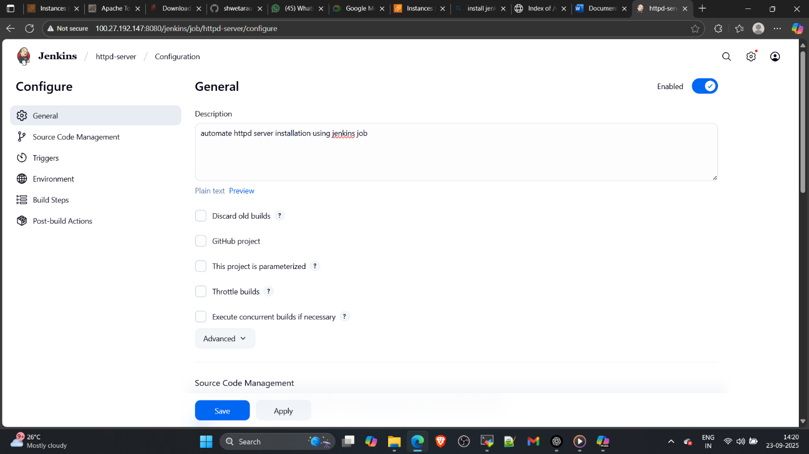

1. Add script for automationin build steps

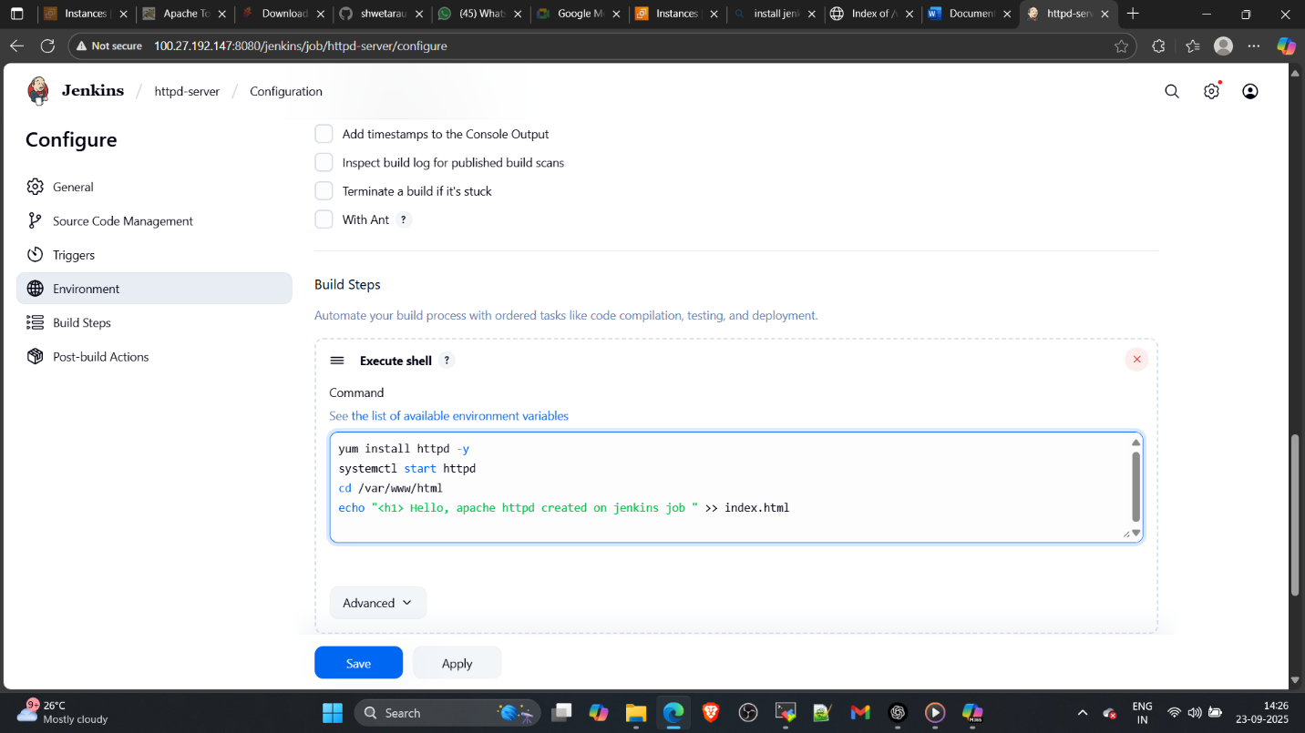

8. Build it

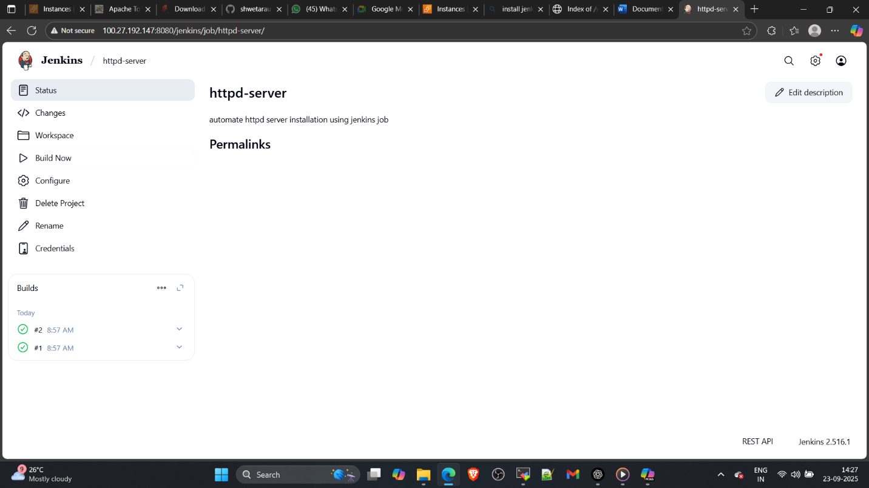

9. see jobs in backend

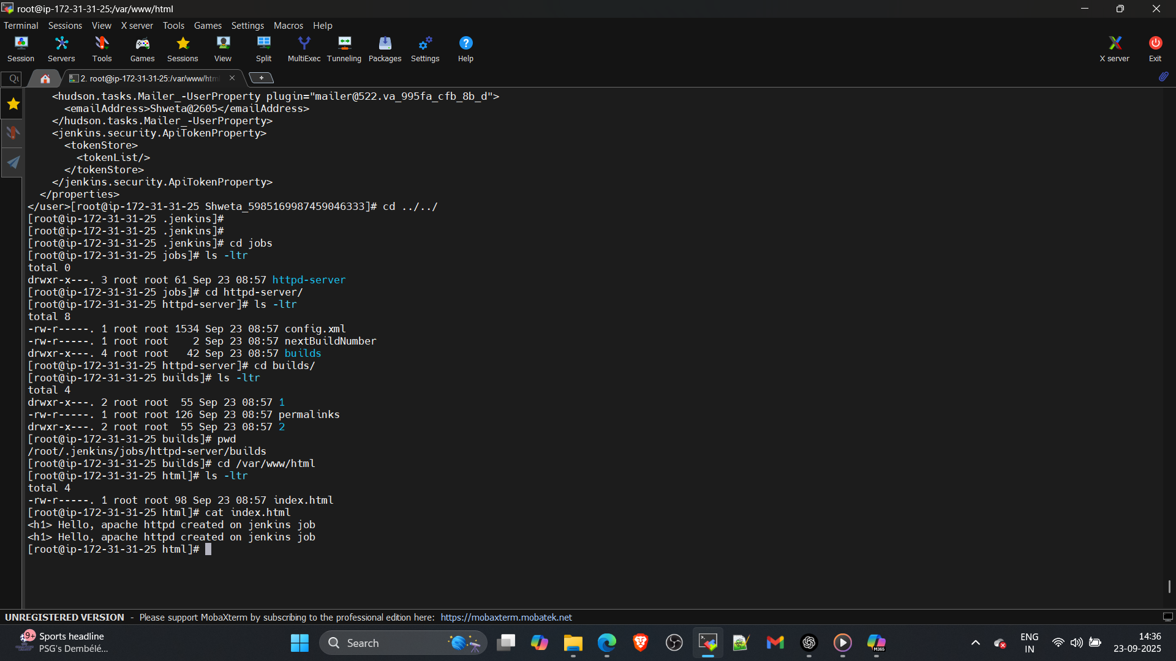

10. Verify httpd is working !!!

